**Lab 1: Hello World                Date: 03/02/2020**

**Exercise 1: Types**

**Question**: Using the “Hello World” program as a starting point, write a program that prints out the size in bytes of each of the fundamental data types in C++.

**Solution**:

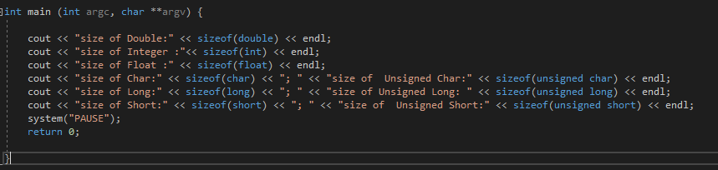

**Sample Output:**

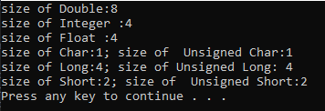

**Exercise 2: Floating point Precision**

**Question:**

How small does y have to be before you get a “divide by zero” error?  Does the value of x affect the result?

**Solution:**

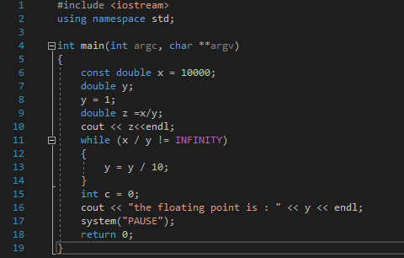

**Sample Test Data:**

|  |  |
| --- | --- |
| **Input** | **Output** |
| 10 | 1e-308 |
| 100 | 1e-307 |
| 1000 | 1e-306 |
| 10000 | 1e-305 |
| 100000 | 1e-304 |
| 100000 | 1e-303 |

**Exercise 3: Iteration Comparison**

**Question:** Below is some C# code that calculates the factorial of a number (see for details of a factorial).  Port this code in to C++.  Reflect on what you have to change or not change from C# to C++ in terms of the iteration.

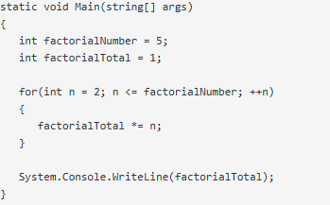

**Solution:** 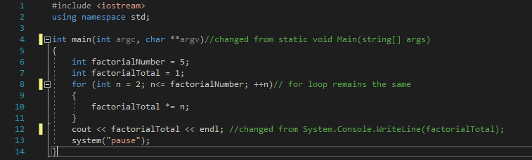

**Reflection:**

In Experiment 1, I learned about the different sizes of the different fundamental data types and the use of the SizeOf() method which tells you their sizes in bytes.

In Experiment 2, I learned about the precision of the double operator and how two numbers that may look identical might only be identical to a certain degree depending on how many decimal places you decide to look at.

In Experiment 3, I learnt the difference in syntax between the C# and C++ language, and how there are similarities in certain operations as well.